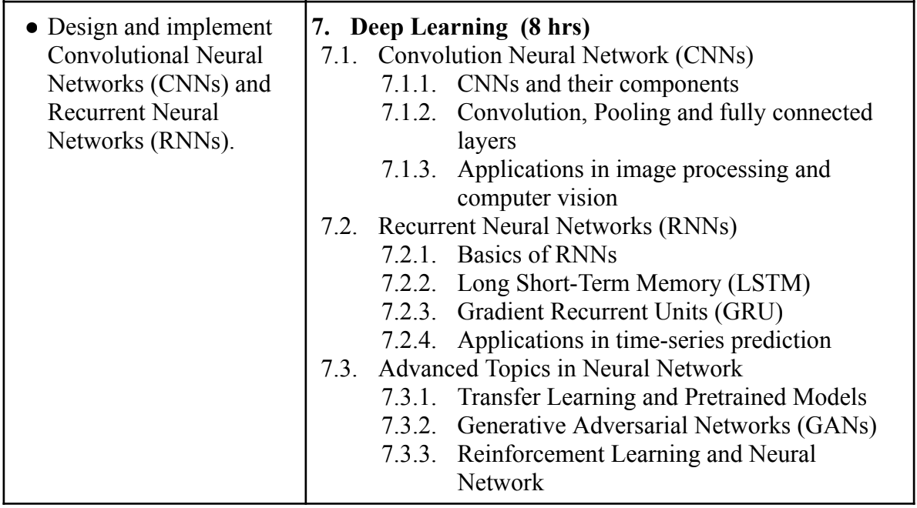

1. Explain the architecture of a Convolutional Neural Network (CNN) and describe its major components. Discuss how each component (Convolutional layers, Pooling layers, and Fully Connected layers) contributes to the overall learning process.
2. Compare CNNs with traditional Artificial Neural Networks (ANNs) and justify why CNNs are preferred for image-related tasks.
3. What is the role of the convolution operation in CNNs? Explain how filters (kernels) help in feature extraction.
4. How does stride and padding impact the output of a convolutional layer? Illustrate with examples.
5. Explain different types of pooling (max pooling, average pooling, and global pooling) and discuss how they affect CNN performance.
6. Discuss how CNNs are used in various image processing tasks such as object detection, image classification, and segmentation.
7. Provide a case study on a real-world application of CNNs in computer vision, such as autonomous driving, medical imaging, or facial recognition.
8. Compare traditional CNN architectures (such as LeNet, AlexNet, VGG) with modern architectures like ResNet, Inception, and EfficientNet.
9. Explain the basic architecture of Recurrent Neural Networks (RNNs) and describe how they differ from feedforward networks.
10. Discuss the problem of vanishing gradients in RNNs and explain why they struggle with long-term dependencies.
11. Provide an example of how RNNs can be used for sequential data processing, such as speech recognition or natural language processing.
12. Explain the internal structure of an LSTM cell, describing its gates (input gate, forget gate, output gate).
13. Compare LSTM with traditional RNNs and discuss scenarios where LSTM would be preferred over simple RNNs.
14. What are Gated Recurrent Units (GRU), and how do they differ from LSTM networks? Explain the internal mechanisms of GRUs, highlighting the role of the reset gate and update gate.
15. Compare GRU and LSTM in terms of computational efficiency, memory usage, and performance in real-world applications.
16. Explain the role of RNNs in time-series forecasting and sequential data analysis. Describe a real-world case study where RNNs or LSTMs have been successfully applied in forecasting (e.g., stock market prediction, weather forecasting, energy demand prediction).